Project Design Phase-II
Technology Stack (Architecture & Stack)

Date | 31 January 3035
Team ID | LTVIP2026TMIDS34879
Project Name | Online Payments Fraud Detection Using Machine Learning
Maximum Marks | 4 Marks

Technical Architecture:
The Deliverable shall include the architectural diagram as below and the information as per the table1 & table 2
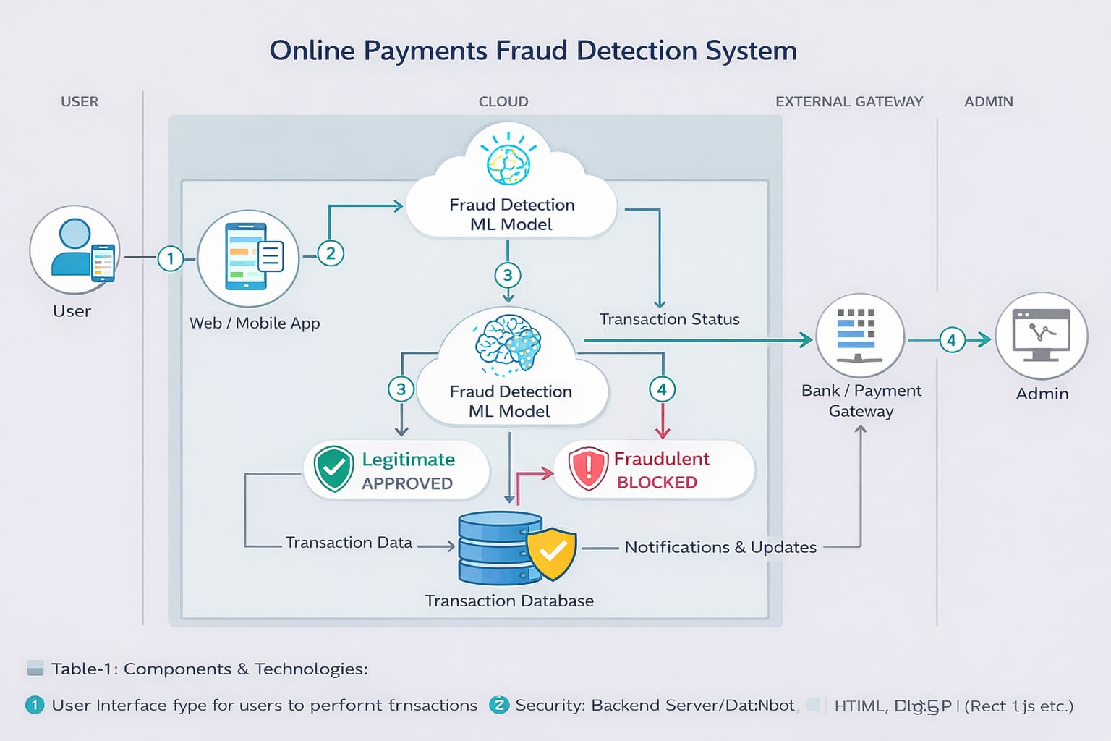

Table-1 : Components & Technologies:
S.No | Component | Description | Technology
1 | User Interface | Web/mobile interface for users to perform transactions | HTML, CSS, JavaScript, React
2 | Application Logic-1 | Handles user authentication & transaction processing | Python (Flask / Django)
3 | Application Logic-2 | Data preprocessing & feature extraction | Python (Pandas, NumPy)
4 | Application Logic-3 | Fraud detection using ML model | Scikit-learn / TensorFlow
5 | Database | Stores user and transaction data | MySQL / PostgreSQL
6 | Cloud Database | Scalable storage for large transaction datasets | Firebase / AWS RDS
7 | File Storage | Stores logs, datasets, and model files | Local Storage / AWS S3
8 | External API-1 | Payment gateway integration | Razorpay / Stripe API
9 | External API-2 | OTP / Notification services | Twilio / Firebase OTP
10 | Machine Learning Model | Detects fraudulent transactions | Logistic Regression / Random Forest
11 | Infrastructure (Server/Cloud) | Deployment environment | AWS / Azure / Local Server

Table-2: Application Characteristics:
S.No | Characteristics | Description | Technology
1 | Open-Source Frameworks | Used for backend and ML model development | Flask, Django, Scikit-learn
2 | Security Implementations | Data encryption, authentication, fraud protection | SSL, SHA-256, JWT, OAuth
3 | Scalable Architecture | System supports increasing users & transactions | Microservices, Cloud Deployment
4 | Availability | System available 24/7 with minimal downtime | Cloud Hosting, Load Balancer
5 | Performance | Real-time fraud detection with fast response | Caching, Optimized ML models

